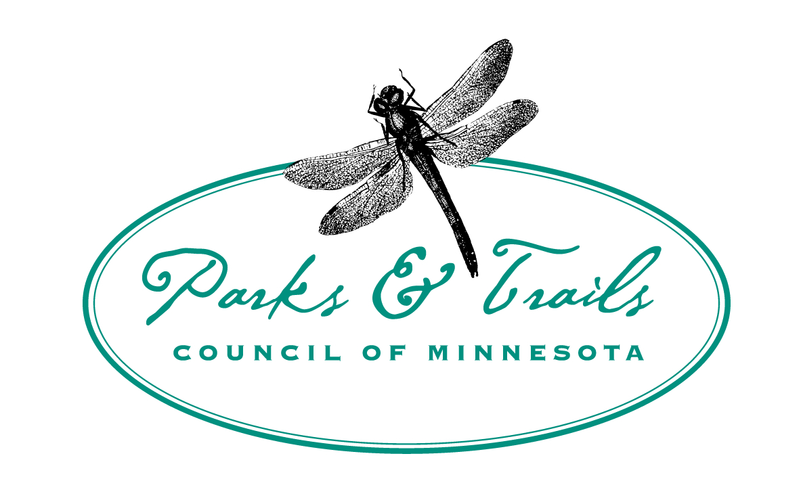

Application for Liability Insurance
Friends Group Partners have the opportunity to obtain a Certificate of Liability Insurance under Parks & Trails Council. Submit this application form to see if the event qualifies for coverage.

Friends Group Contact Information
Friends Group: ____________________________ Contact: ____________________________
Email: ___________________________________ Phone: _____________________________
Organization Requesting Certificate of Insurance Contact Information
Requesting Organization (i.e. DNR): ________________________________________________
Address: ______________________________________________________________________
Contact: _________________________________ Email: ______________________________
Event 1 Details
Event Name: __________________________________________________________________
Event Date: __________________________ Event Times: _____________________________
Event Description ______________________________________________________________
and Activities: ______________________________________________________________
_______________________________________________________________
Number of Participants Expected: _________________________________________________
Number of Volunteers Expected: __________________________________________________
Will volunteers be using motorized vehicles or power tools? Yes No
If so, what tools/vehicles and who owns them? _______________________________________
______________________________________________________________________________
Event 2 Details
Event Name: __________________________________________________________________
Event Date: __________________________ Event Times: _____________________________
Event Description ______________________________________________________________
and Activities: ______________________________________________________________
_______________________________________________________________
Number of Participants Expected: _________________________________________________
Number of Volunteers Expected: __________________________________________________
Will volunteers be using motorized vehicles or power tools? Yes No
If so, what tools/vehicles and who owns them? _______________________________________
______________________________________________________________________________
Event 3 Details
Event Name: __________________________________________________________________
Event Date: __________________________ Event Times: _____________________________
Event Description ______________________________________________________________
and Activities: ______________________________________________________________
_______________________________________________________________
Number of Participants Expected: _________________________________________________
Number of Volunteers Expected: __________________________________________________
Will volunteers be using motorized vehicles or power tools? Yes No
If so, what tools/vehicles and who owns them? _______________________________________
______________________________________________________________________________

If there are additional events a Certificate of Insurance is needed for, either copy/paste the event details section or append another copy of this form.

When a Certificate of Insurance is issued, the Friends Group understands the following:
- Parks & Trails Council of MN must be listed as an event co-sponsor on distribution materials. The P&TC logo will be provided.
- The Friends Group must obtain signed waivers from event participants. A waiver template will be provided. If a different waiver is used, it must be approved by P&TC.
- The liability insurance is only valid on the date of the event for event activities.

For office use only:
Approve/Deny: Initial _________ Date _________
Sent to Ins.: Initial _________ Date _________
Issued: Initial _________ Date _________
_____________________________________
Signature

_____________________________________
Date

